Milestone 2

In this build, both the target and hoop games are complete, with just the hammer game left to go, which should be relatively simple to complete with some minor modifications to the existing code while adding functionality for targets to change between being a valid target or not, along with changing colour from green to red, and vice versa. I will then finish work on the environment and the textures, and add sound, before working on the presentation.

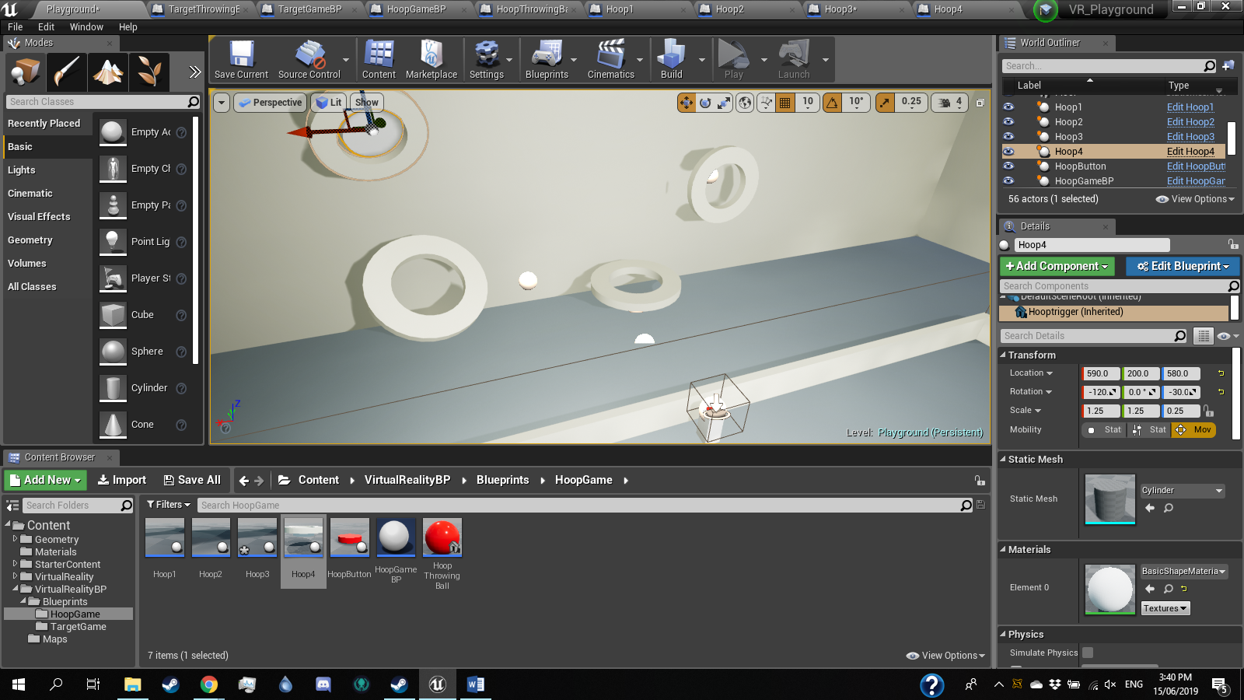

I do not plan to remove any planned features at this stage. I will however and a panel with three lights that will activate with each minigame that is completed. Once all three games are complete, the player will be able to interact with the panel to end the level. I will also create a menu area where the player ill be able to start the game from.

The presentation will explain the state of the build of the game, provide a manual for the game, and give a conclusion f the builds development process.